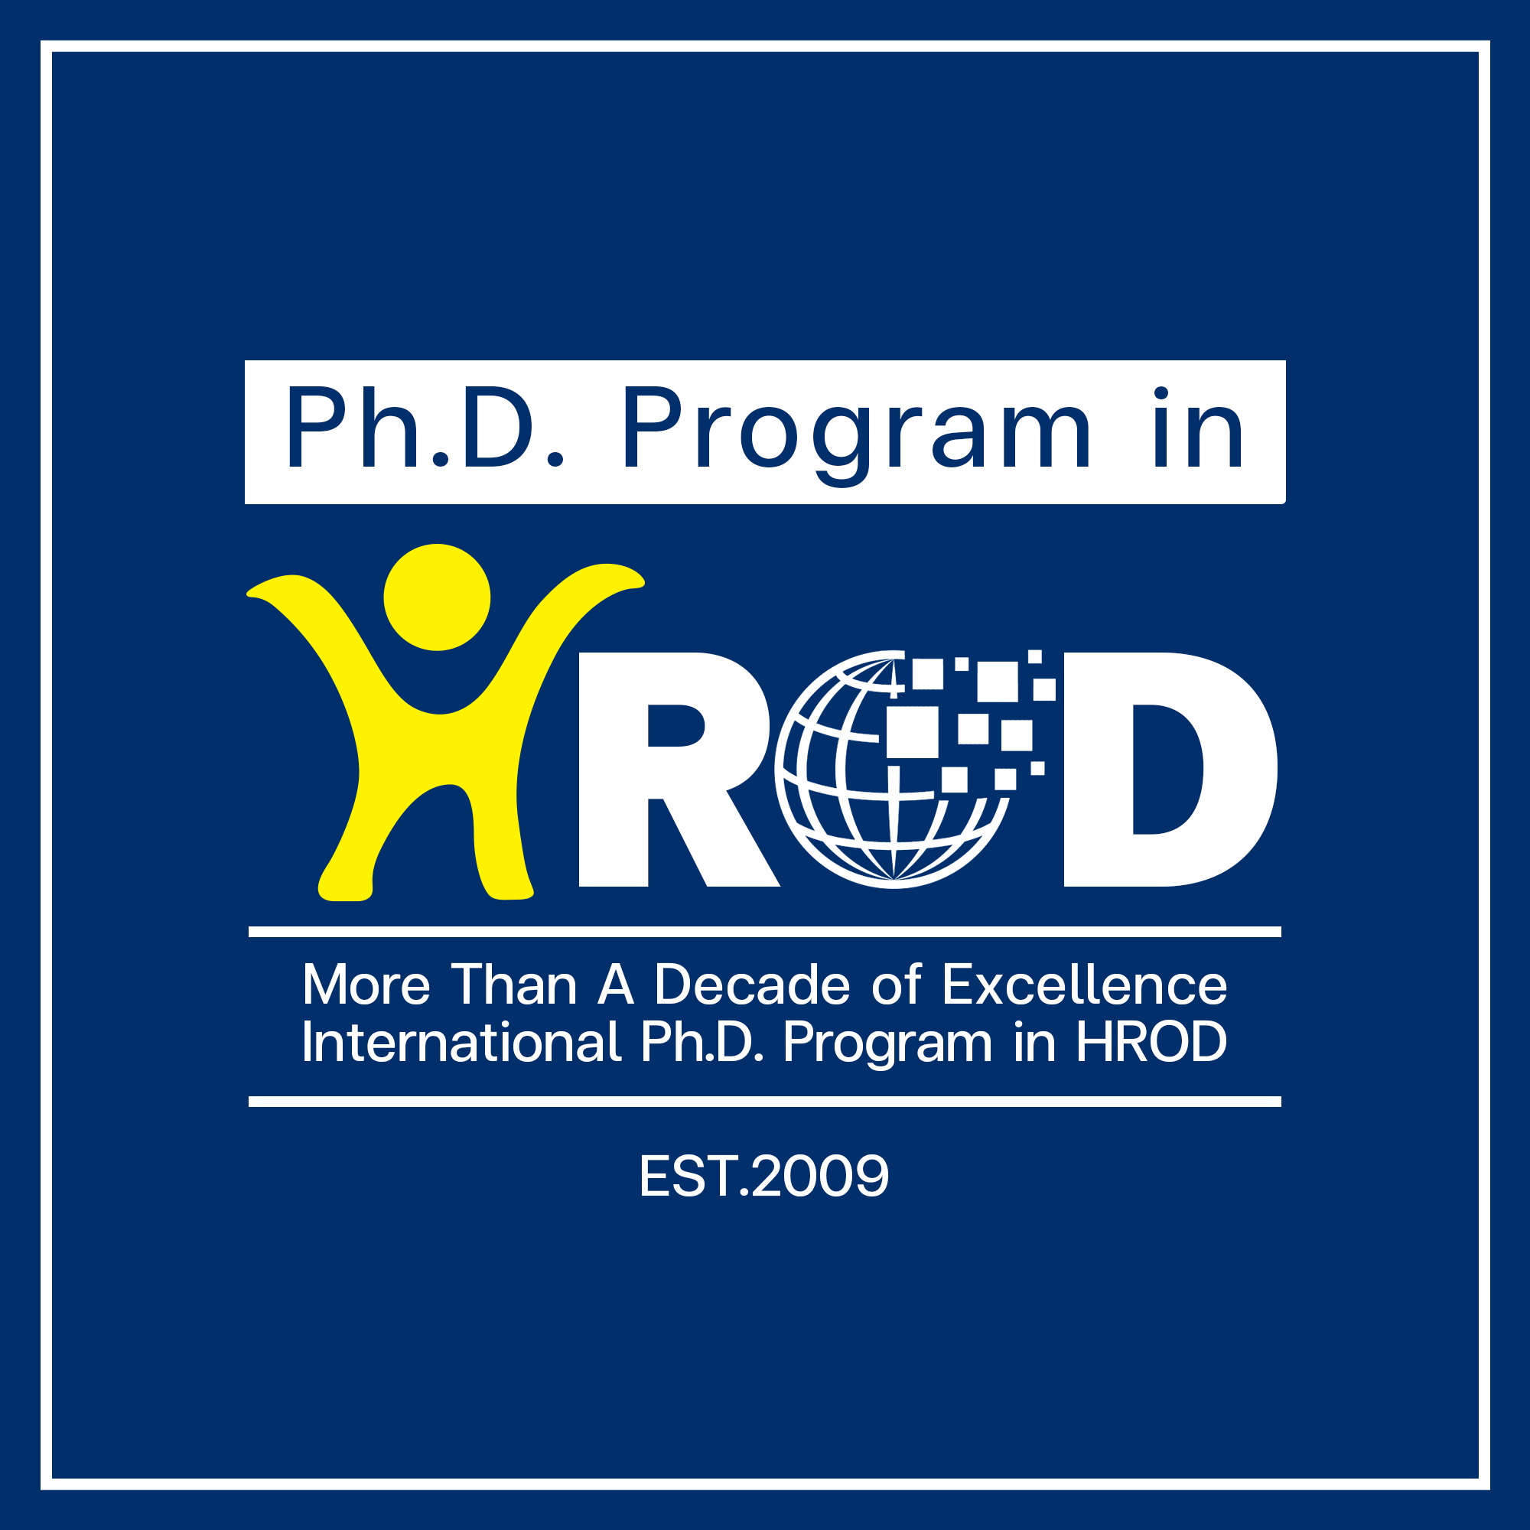
Application Form
Graduate School of Human Resource Development
National Institute of Development Administration

148 Moo3, Serithai Road, Klong-Chan, Bangkapi, Bangkok 10240 THAILAND

WEB: EMAIL: PHONE: FAX:
www.hrd.nida.ac.th/hrd-phd/ Teerapast.kas@nida.ac.th 66-2375 3876-79 66-2378 001
Please place your
PHOTO here
☺

Application for Admission For Academic Year _____2025______
Please ensure that all sections of this form are completed,, sign and date the application, and return it along with all required materials..
Study Plan:
 PLAN 1: Research Plan for master’s degree holder
 PLAN 2 (2.1): Coursework Plan for master’s degree holder
 PLAN 2 (2.1) Track A : Blended Learning (Onsite 45%, Online 55%)
 PLAN 2 (2.1) Track B : Online Learning (Onsite 5%, Online 95%)
 PLAN 2 (2.1) Either Track A or Track B is fine.
 PLAN 2 (2.2): Coursework Plan for bachelor’s degree holder

Scholarship Request:
Are you interested in applying for the scholarship?
 Yes (Please complete scholarship request form on page 4)
 No
Biographical Information
Gender   Male   Female   Non-Binary   Prefer not to say. | Last Name First Middle  Your Name in Thai (optional):
Current Mailing Address / Telephone Numbers / E-mail Address

Home : ______________________________________________________________________________________ Telephone/Mobile : ___________________________ E-mail : ____________________________________
Permanent Mailing Address and Telephone Number
Home : ______________________________________________________________________________________
Telephone/Mobile : ___________________________

Date of Birth : dd/mm/yyyy |  | Thai Identification Number / Passport Number :
If you are NOT a THAI citizen, please indicate your current immigration status in Thailand.

 THAILAND Alien Registration Number _________________________________________

 Non-Immigrant Visa type _____________________________
Important NOTE: In order to register as a student, NIDA requires that applicants who are not THAI citizens or THAI permanent Residents obtain and maintain an appropriate visa status for their stay in Thailand.

Major Honor /Award/ Academic and/or Professional Achievement (If any)
English Proficiency Test Score |  | Score |  |  |  | Test Date
 TOEFL
 IELTS (Academic)
 TOEFL / ITP
 Dulingo
NOTE: Note: Applicants may submit a TOEFL score of 500 (NIDA ITP paper-based), 500 (paper-based), 173 (computer-based), or 61 (internet-based), an IELTS score of 5.0, or a Duolingo Test score of at least 90, or a TOEFL ITP score of at least 500 from another institution. These scores may be accepted under the condition that the applicant takes and passes at least two English courses required by the School of Language and Communication, NIDA, and submits the minimum required TOEFL score of 550 (NIDA ITP paper-based), 550 (paper-based), 213 (computer-based), 79 (internet-based), or an IELTS score of at least 6.5 before graduation.
*** Except for applicants who either come from English-speaking nations or have graduated from an undergraduate program that used English as the medium of instruction within the last five years.
Work Experience: List all previous and present works.

Name of Company/Organization |  |  | Position Title |  |  |  | Year
Have you ever attended/enrolled in any course at NIDA?  Yes  No
If yes, please provide the school’s name and the year of study.

_______________________________________________________________________________________

Academic Background
List every college and university where you have attended full-time for one academic year or more, as well as any degree program in which you are currently enrolled. Please list schools chronologically, starting with your undergraduate degree first.
Collage / University | From: To:  (Month & Year) |  |  | Majors | GPA |  |  | Degree or Diploma earned / expected
Research Experience (If any)
Please provide details of any research projects you have been involved in. Include information about your role, the objectives of the research, and any outcomes or findings. This can include undergraduate or postgraduate research, as well as any professional research experience.
___________________________________________________________________________________________________
____________________________________________________________________________________________________
____________________________________________________________________________________________________
____________________________________________________________________________________________________
________________________________________________________________________________________________________________________________________________________________________________________
Publications and Academic Contributions (If any)
Please list any publications or academic contributions you have made. This includes articles in journals, conference papers, book chapters, or other scholarly publications.
____________________________________________________________________________________________________
____________________________________________________________________________________________________
____________________________________________________________________________________________________
____________________________________________________________________________________________________
___________________________________________________________________________________________________
What are your research interests? (If any)
____________________________________________________________________________________________________
____________________________________________________________________________________________________
Disciplinary and Legal History
The purpose of these questions is to gather relevant information regarding your disciplinary and legal history. Answering “yes” to these questions does not automatically disqualify you from admission but may require further explanation. Please provide details if your answer is 'yes' to any of the above questions.
1. Have you ever been suspended or dismissed from any school or college? Yes  No

2. Have you ever been convicted of a felony?  Yes  No
If you have not graduated yet, what is the proposed date of your graduation (mm/yyyy)?

Please tell us how you learned about our program :

Please list any honors, fellowships, and academic/professional awards you have received that most clearly reflect your success or potential in doctoral study within our program, if applicable

Contact person at the certified organization/agency we could contact to verify your honor/award mentioned above. Attach additional sheets as needed.
Name ___________________________________ Position _______________________________________
Telephone __________________________________Email ________________________________________
or Affiliation / Organization _________________________________________________________________

Who will support your study financially?
 Self Support  Organization  University  Other sources ………………………
I hereby certify that all information given in this application is correct, and true to the best of my knowledge at the date signed. I understand that giving false information or withholding information may result in my ineligibility for admission or to continue my enrollment at the NIDA
Signature |  | Date
Do Not Write Below This Line : For Office Use Only
NOTE: All admission materials submitted become the property of the National Institute of Development Administration and cannot be forwarded or returned. They will be kept confidentially and be active for a 12-month period only.
Admission Action :  Approve   Not Approve |  |  | Date :
Remark : |  |  | By :
Scholarship Request:
Are you interested in applying for the scholarship?  Yes  No
Which Type of the scholarship are you interested in? (Check all that apply)  Type 1  Type 2  Type 3
Types of Scholarship: | Condition:
Type 1  - 3-year scholarship (under condition)  - Tuition and fees exemption  (THB 8,500 per credit)  - Monthly stipend from the institution. (The recipients will receive financial support for personal expenses: 30,000.- baht per semester and 15,000.- baht per summer semester.) | - Bachelor’s degree GPA of 3.00 or above  - Master’s degree GPA of 3.50 or above  - The student must maintain GPA at the minimum of 3.50. If students fail to perform accordingly, the monthly stipend from the institution will be terminated.  - Students must maintain GPA at the minimum of 3.30. If students fail to perform accordingly, the scholarship will be terminated.  - Scholarship recipients must complete the degree in accordance with the program’s requirement without any kind of academic suspension or leave from the program. Failure to do so, the total of the scholarship must be reimbursed to the program as students’ responsibility.  - Withdrawing from or failing to complete a course with a grade of “C” or better will result in termination of scholarship.  - For Plan 2 (Coursework Plan), Scholarship recipients are responsible to pay students activities fee of THB 30,000 per semester (Total of THB 120,000)  *The program requires scholarship recipients to study in the program on a full-time basis*  (Full-time students are not allowed to be employed full-time)
Type 2  - 3-year scholarship (under condition)  - Tuition and fees exemption  (THB 8,500 per credit)  - This scholarship type does not cover the administration fee, library fee, IT fee, and qualifying examination fee | - Bachelor’s degree GPA of 2.75 or above  - Master’s degree GPA of 3.50 or above  - Students must maintain GPA at the minimum of 3.30. If students fail to perform accordingly, the scholarship will be terminated.  - Scholarship recipients must complete the degree in accordance with the program's requirement without any kind of academic suspension or leave from the program. Failure to do so, the total of the scholarship must be reimbursed to the program as students’ responsibility.  - Withdrawing from or failing to complete a course with a grade of "C" or better will result in termination of scholarship.  - For Plan 2 (Coursework Plan), Scholarship recipients are responsible to pay students activities fee of THB 30,000 per semester (Total of THB 120,000)
Type 3  - 3-year scholarship (under condition)  - Partial tuition and fees exemption  (THB 4,250 per credit)  - This scholarship type does not cover the administration fee, library fee, IT fee, and qualifying examination fee | - Bachelor’s degree GPA of 2.75 or above  - Master’s degree GPA of 3.50 or above  - Students must maintain GPA at the minimum of 3.30. If students fail to perform accordingly, the scholarship will be terminated.  - Scholarship recipients must complete the degree in accordance with the program's requirement without any kind of academic suspension or leave from the program. Failure to do so, the total of the scholarship must be reimbursed to the program as students’ responsibility.  - Withdrawing from or failing to complete a course with a grade of "C" or better will result in termination of scholarship.  - For Plan 2 (Coursework Plan), Scholarship recipients are responsible to pay students activities fee of THB 30,000 per semester (Total of THB 120,000)

